Exercise 5: Configuring the Spring IoC Container
1) creating a maven project “LibraryManagementSystem”
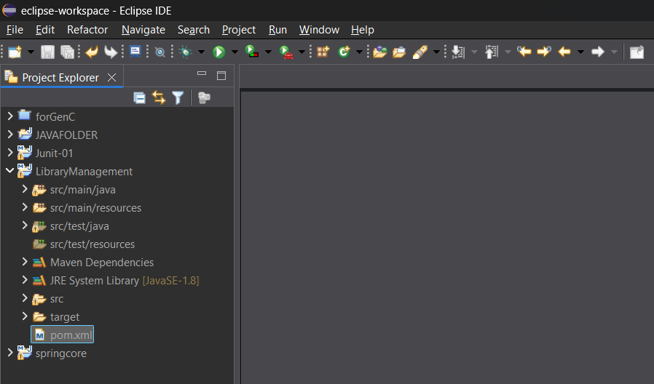
2)add the spring core and spring context dependencies in the pom.xml file
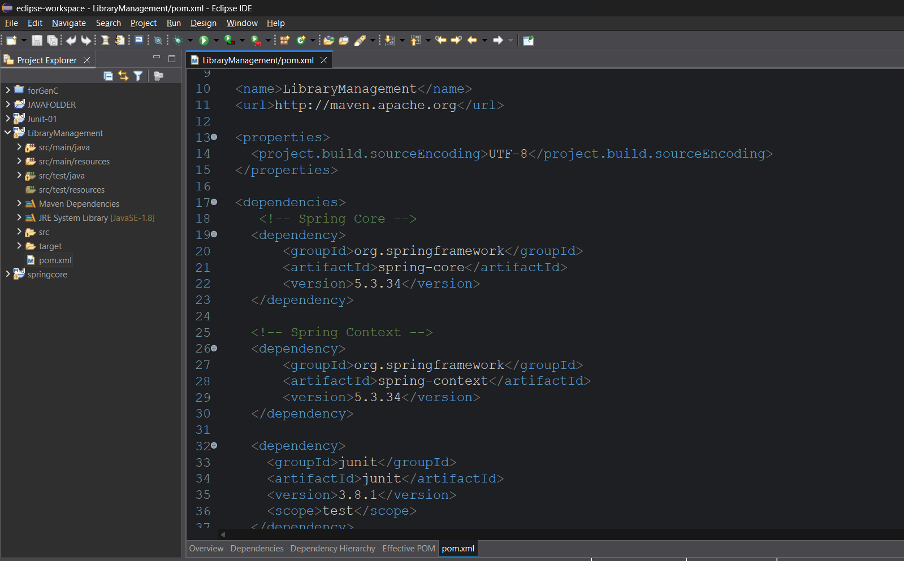
3) create BookRepository and BookService classes in the com.library.repository and com.library.service packages repectively
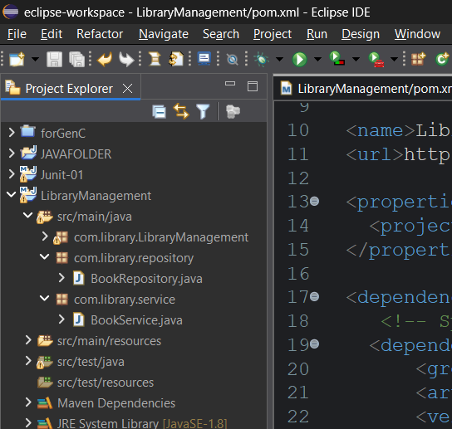
4)BookRepository.java:
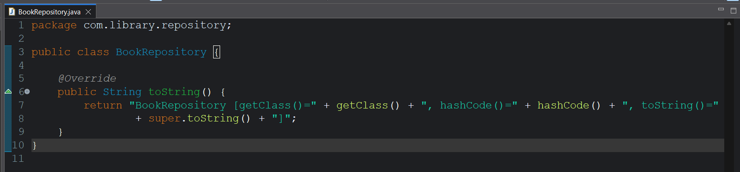
BookService.java:
In the BookService class declare a variable of type BookRepository and write a setter method to initialize it.

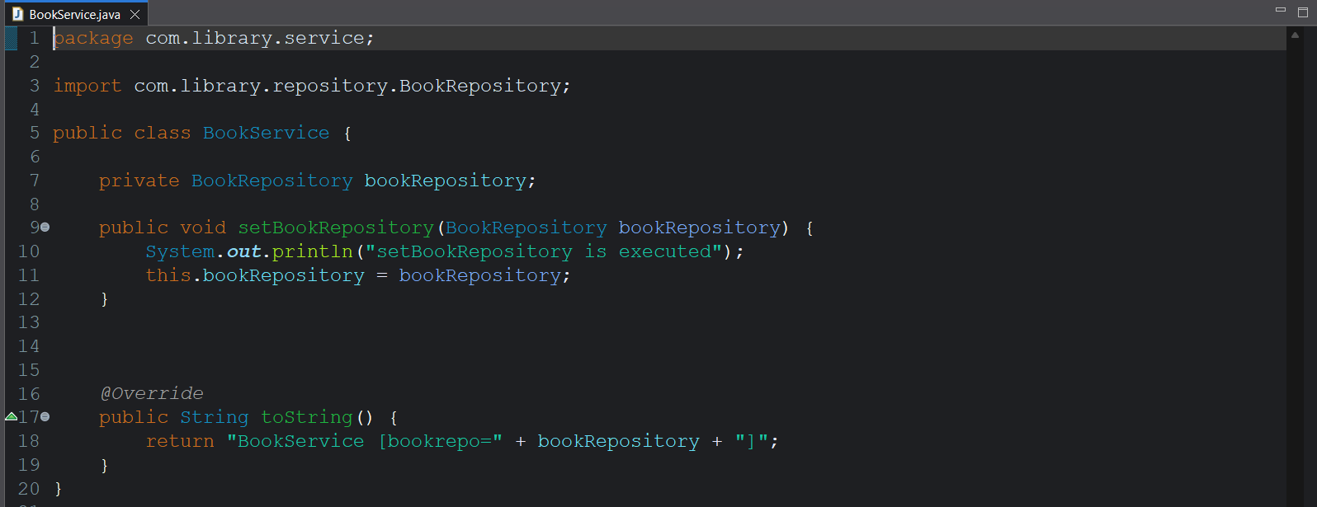
5)create a applicationContext.xml file in src/main/resources
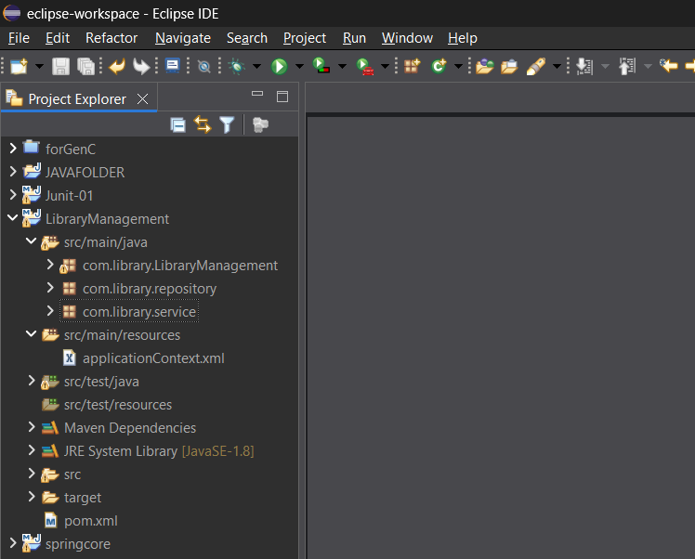
6) set up the bean configuration in the applicationContext.xml
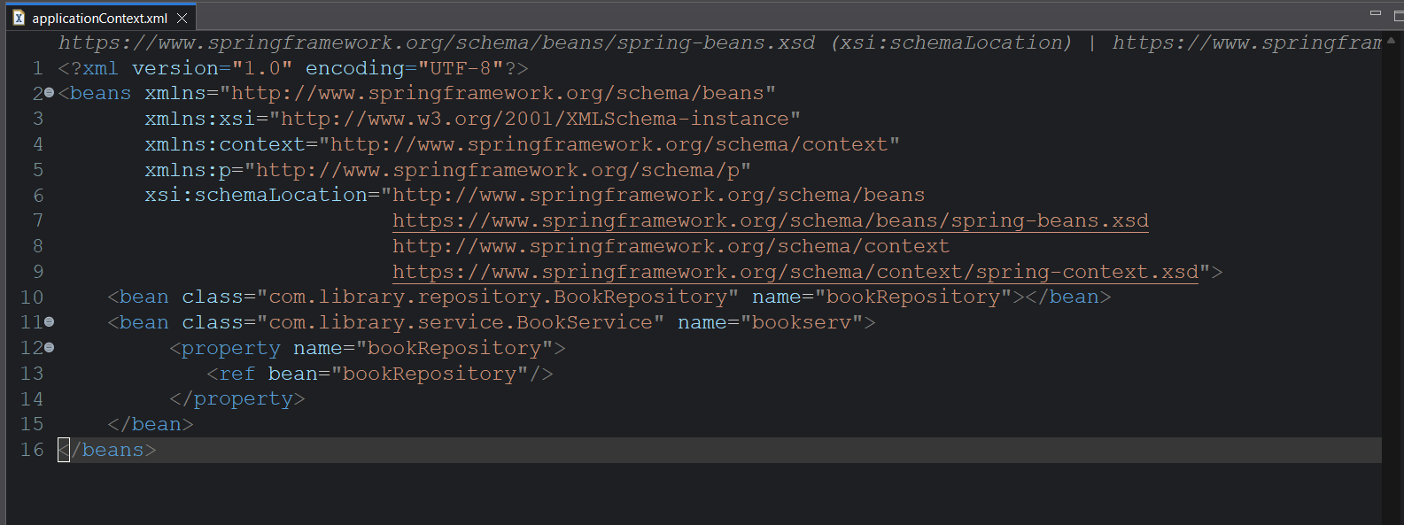
7)write the beans for both the classes
And the bean of BookService references BookRepository bean

8) create a Test class with main method in src/main/tests
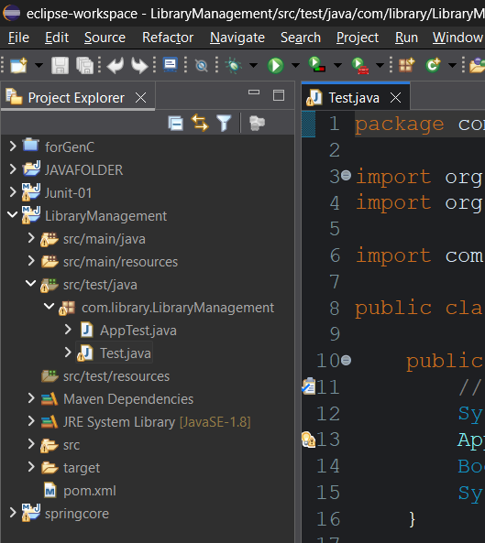
9) 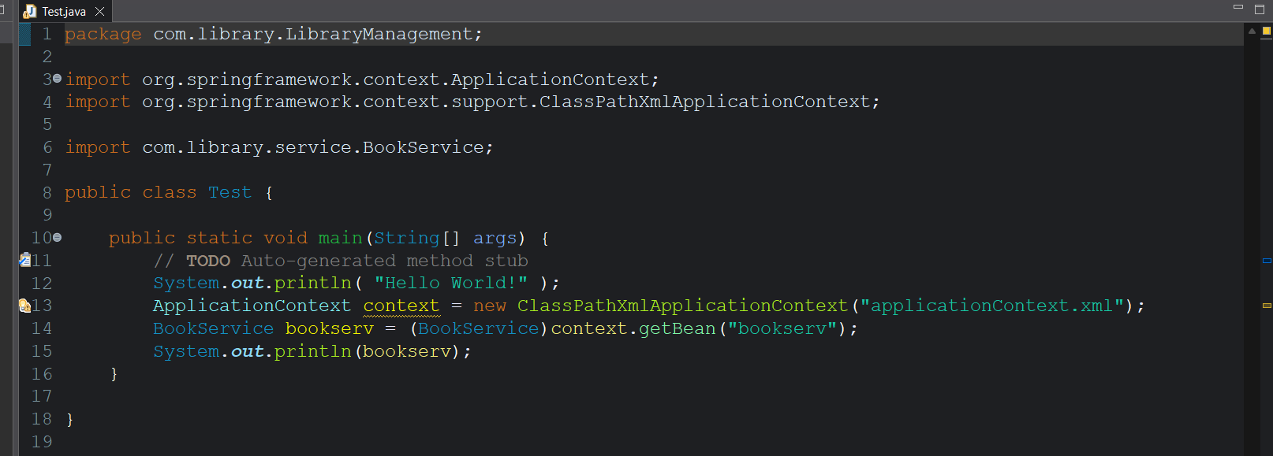

Output:
